Plan B’s Image
The album covers for Plan B’s first album “Who Needs Actions When You Got Words” connotates a grim, basic existence. Plan B sitting in the centre of this bare room demonstrates his poor background.
Plan B taught himself how to play guitar at 14, first playing Blur and Oasis with friends,^{[5]} then going on to write his own R&B love songs. At 18, feeling uncomfortable with R&B, he turned towards rap and hip hop music and wrote "Kidz", inspired by the murder of Damilola Taylor.
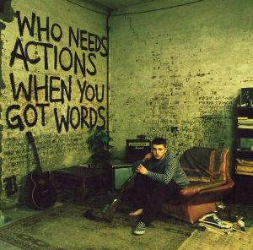
Growing up, Plan B felt outcast from the rest of the school pupils.
"We weren't working class but we weren't middle class, we were in the void in-between. I've always felt like a social outcast."
Commentary: Plan B represents the hard-working underdog, the idea that one can start with so little and go on to do greater things through music. This image is an important part of his fan base, as many listeners find his image and his lyrical content easily identifiable. Although recently it can be argued that his audience may have changed due to the different genre of his latest album, The Defamation of Strickland Banks.
Plan B’s subsequent crossover
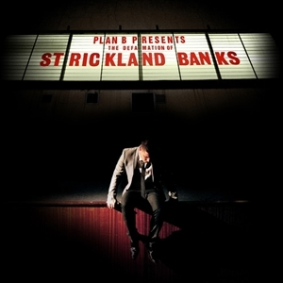
Plan B had always wanted to make his second album as a concept album and he had previously abandoned an attempt to make a hip hop follow up to his debut Who Needs Actions When You Got Words. After learning more about the technical aspects of singing. And having already written some soul songs such as "Love Goes Down", he went on to create The Defamation of Strickland Banks which was a combination of soul, blues and rap.
Due to this dramatic change in musical style towards a more mainstream sound, Plan B also changed his associated image from being a more controversial grime/hip hop artist to a more sophisticated, materialistic singer/songwriter. As a result of musical and image changes, Plan B’s audience changed.

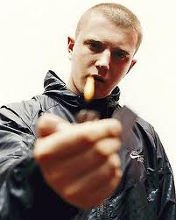

In contrast with the previous album cover, Plan B is now presented as a more sophisticated, glamorous artist. Notice how the album title is in neon lights compared to the last album which was graffiti.

